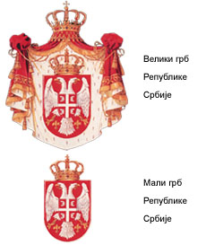
The Republic of Serbia
The Government of the Republic of Serbia
THE ANTI-CORRUPTION COUNCIL
No:
Belgrade, 1 December 2004

THE GOVERNMENT OF THE REPUBLIC OF SERBIA
- Vojislav Kostunica, Prime Minister -

Dear Mr. Prime Minister,

The Anti-Corruption Council calls upon you to stop the sale of the business premises of the Money Transfer Service Office (ZOP), which has been already used free of charge for three years by the private National Savings Bank /“Nacionalna štedionica”/ under an agreement made with Mladjan Dinkic, the then Governor of the National Bank of Yugoslavia.

On 24 November 2004, the daily newspaper “Danas” published an advertisement for the sale of the state-owned business premises and accompanying equipment, which we consider to be the continuation of one of the greatest examples of illegal disposal of state-owned property, of which you will convince yourself from the Report on the National Savings Bank prepared by the Council and which we shall forward to you by Monday.

We assure you that it is necessary to stop this tender this very day and point to the decisive fact that confirms it for you – the bidding period is eight days from the day of the publication, i.e. the bids will be opened tomorrow on 2 December 2004. The actions that would have to be taken by a party interested in buying the best business premises in Serbia cannot be completed in eight days, and the normal bidding period is 60 days. Only someone who has been acquainted with all this in advance and for whom the tender has been prepared can prepare and submit his bid within a period of eight days, and that party is the National Savings Bank.

Yours faithfully,

PRESIDENT

Verica Barac

